**Lab 2 Configuring the Windows Server 2016 Environment**

Task 3 – Activities (Save your work because your answers may be required to provide in the Mid- Semester and Final Examination.)

**Activity 2-1: Installing and Removing a Server Role**

**Time Required**: Approximately 15 minutes

**Objective**: Install and then remove the Print and Document Services role in Windows Server 2016.

**Description**: Windows Server 2016 offers a wide range of roles on a server- based

network. In this activity, you use Server Manager  to  install  the  Print  and  Document services role and then you practice removing this role. The activity is designed to give you additional experience installing a server role and  the  opportunity to learn how to remove a role you have installed.

**Requirements**: Take screenshots for Step 7, 10, and complete a question in Step 15

1. Ensure that Server Manager is open. If you need to open it, click Start and click the Server Manager tile.

2. Ensure Dashboard is selected in the left pane.

3. In the right pane, click Add roles and features under Welcome to Server Manager.

4. If you see the Before you begin window in the Add Roles and Features Wizard, click Next.

5. Make sure that Role-based or feature-based installation is selected in the Select installation type window. Click Next.

6. Ensure your computer is selected in the Server Pool box in the Select destination server window and click Next.

7. In the Select server roles window, check the box for Print and Document Services. If you see a dialog box to add features required for a role, such as remote server administration tools, click Add Features.

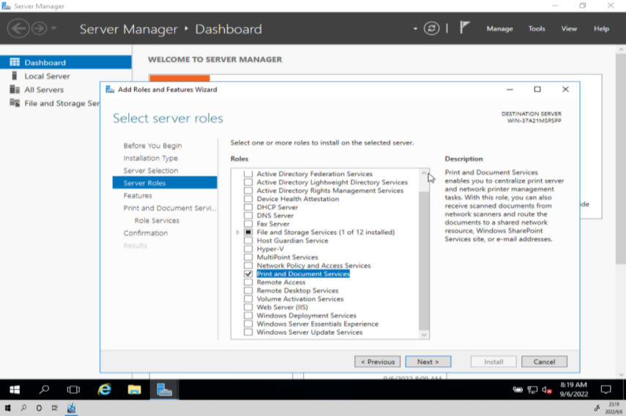

Figure 1.1 Check the box for Print and Document Services

8. Click Next in the Select server roles window.

9. Click Next in the Select features window.

10. In the Print and Document Services window, read the information about the Print and Document Services role and note that there is a link to learn about this role. Click Next.

Figure 1.2 The information about the Print and Document Services role

11. In the Select role services window, make sure Print Server is selected (the default), and click Next.

12. Click Install in the Confirm installation selections window.

13. Wait for a few minutes as the role is installed.

14. When the Installation progress window shows that the installation succeeded, click Close.

15. In the left pane of Server Manager, select Print Services and scroll through the right pane to view the boxes of information for this role.

• What role and role service do you see in the Roles and Features box? Please take a screen shot as a record.

**Role: Print and Document Services**

**Role service: Print Server**

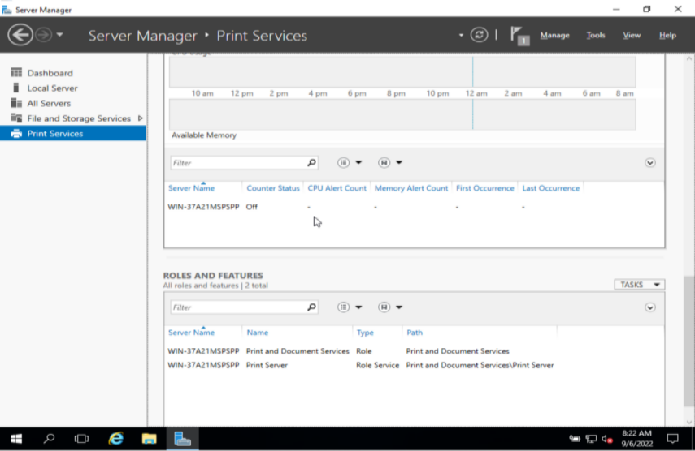

Figure 1.3 The boxes of information for Print Services

16. With Print Services still selected in the left pane, click Manage under the title bar in Server Manager. Click Remove Roles and Features.

17. If you see the Before you begin window in the Remove Roles and Features Wizard, click Next.

18. Ensure your computer is selected in the Server Pool box in the Select destination server window and click Next.

19. In the Remove server roles window, click the Print and Document Services check box and, if necessary, click Remove Features in the Remove Roles and Features Wizard dialog box.

20. Click Next in the Remove server roles window.

21. Click Next in the Remove features window.

22. Click Remove in the Confirm removal selections window.

23. Wait a few minutes for the removal process to complete and then click Close.

24. Close Server Manager.

**Activity2-2: Verifying Critical Files for a Signature**

**Time Required**: Approximately 15 minutes

**Objective**: Use Sigverif to find unsigned files.

**Description**: After you upgrade a server or if you bypass a driver signature warning,

you can check Windows Server 2016 for driver files that are unsigned, which is a good security precaution. Further, you might experience a situation in which unsigned drivers interfere with the normal function of the server—a file that is missed even by the System File Checker. For example, you might install a new disk drive, install the drivers from the manufacturer’s CD/ DVD, and then find that some other peripheral is not working right because it shares a common .dll file. This activity shows you how to use the Sigverif tool to locate the unsigned files that might be the source of the problem and that should be replaced.

**Requirements**: Take screenshots on Step 3, and 7.

1. Open the Command Prompt window, if it is not open (or open Windows PowerShell).

2. Type sigverif at the prompt and press Enter.

3. Click the Advanced button in the File Signature Verification dialog box. Notice the name of the log file that will contain the results of the scan, which is sigverif.txt by default.

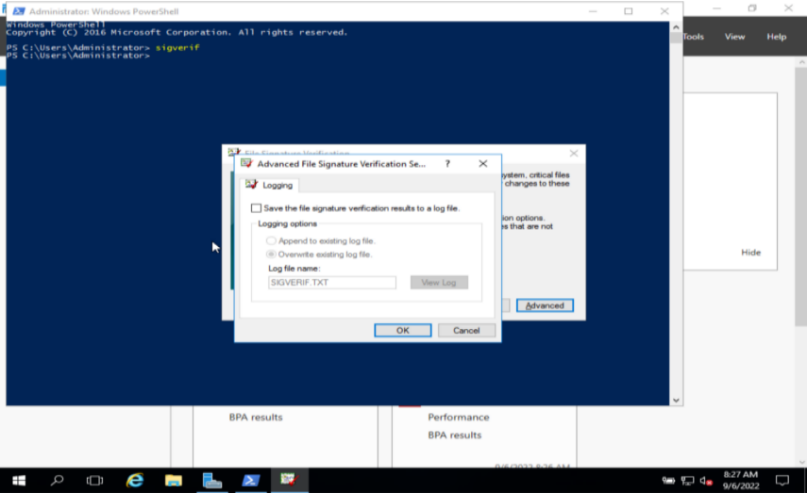

Figure 2.1 The name of the log file that contains the results of the scan

4. Click OK.

5. Click Start.

6. Click OK when the scan is completed and then click Close.